Key Issue 1: Where Is Industry Distributed?
Pages 395-397

***Always keep your key term packet out whenever you take notes from Rubenstein. As the terms come up in the text, think through the significance of the term.
- Regarding the Industrial Revolution: What? Where? When?

- Define cottage industry:

- How did the iron industry benefits from the steam engine?

- How is the distribution of steel and iron industry influenced by coal?

- Why was development in transportation necessary?

- What two forms of transportation grew rapidly?

- How did the Industrial Revolution change textiles?

- How did the Industrial Revolution and factory system contribute to the need for food processing?

- As you read the section, make notes on the resources, advantages, conditions, and issues in each of the sub regions of industrial development discussed. Shade and label each of the regions on the maps. (Use maps on pages 396-397 as guides)

Europe

United Kingdom – | Rhine-Ruhr -
Mid-Rhine – | Po Basin -

Northeastern Spain – | Moscow -
St. Petersburg – | Urals –
Volga - | Kuznetsk -
Donetsk – | Silesia -

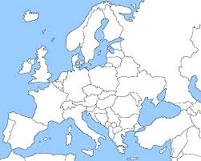

North America

New England – | Middle Atlantic -
Mohawk Valley – | Pittsburgh-Lake Erie -
Western Great Lakes – | Southern California -
Southeastern Ontario –

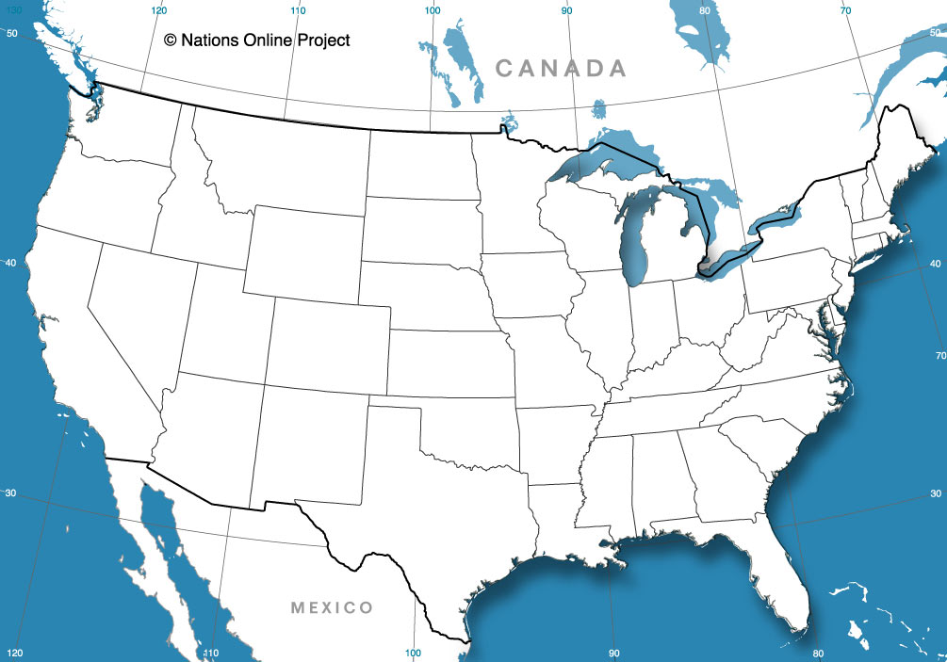

East Asia

Japan – | China -
South Korea –

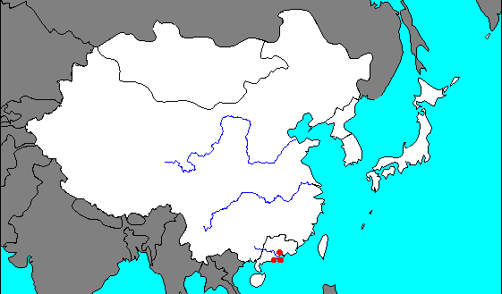

Key Issue 2: Why Are Situation and Site Factors Important?
Pages 398-411
- Define situation factors:

- Define site factors:

- What is a “bulk-reducing industry”?

- What is a “bulk-gaining industry”?

- Give two examples of these industries, and explain how they are bulk-gaining.

- Specialized manufacturers make products that are designed to be sold primarily to
_____________________________________________________.

- Where is their optimum location?

- Describe one example of this phenomenon.

- List examples of “perishable products” that must be located near their markets.

- How is a newspaper highly perishable?

- Give reasons for why each of the following modes of transportation might be selected by a manufacturer to deliver their products to market.

TRUCKS
TRAINS
SHIPS
AIR

- What is a “break-of-bulk point”?

- Give two examples of important break-of-bulk points.

- Make a brief flow chart to illustrate how copper is an example of a bulk-reducing industry.

- How does energy play a role in the situation of copper mills?

The text describes the changing location of steel mills in the U.S. Explain when and why each location was preferred.
- Pittsburgh, southwestern Pennsylvania

- Locations around southern shore of Lake Erie

- Southern Lake Michigan (Gary, Indiana & Chicago)

- East and West Coasts (Trenton, NJ & Los Angeles, CA)

- Why are the newest steel mills (minimills) beginning to move closer to markets and away from inputs?

- Explain how motor vehicle production is a bulk-gaining industry.

- Where are the three regions of assembly plants for vehicle production?

- Why is vehicle production highly clustered?

- What are the three production cost factors associated with the site of an industry? (Memorize Them!)

- Define labor intensive industry:

- Explain the difference between “labor-intensive” and “high-wage” industries.

- Describe the relationship between capital and the computer industry in California.

- What are several factors about a given piece of land that make it attractive to industry and manufacturing?

- What type of worker is required for the textile industry?

- What country accounts for most of the world’s spinning and weaving?

- Why do MDCs play a larger role in textile assembly than LDCs?

Key Issue 3: Where Does Industry Cause Pollution?
Pages 412-417
Bullet key information for each sub section for each of the three types of pollution geographers worry about.
Air Pollution
Global Scale
Regional Scale
Local Scale

Solid Waste Pollution
Sanitary Landfill
Hazardous Waste

Water Pollution
Sources
Impact

Key Issue 4: Why Are Situation and Site Factors Changing?
Pages 418-424
- How are manufacturing jobs shifting in the U.S.?

- Define right-to-work laws:

- Why are southern right to work states attractive to companies?

- Why has textile production moved from the northeast to the southeast?

- What are the convergence regions?

- What are the competitive and employment regions?

- What makes central Europe attractive to manufacturers?

- Where has industry shifted internationally? And, name each regions leading industrial country(s).

- Why do transnational corporations transfer work to LDCs?

- Define outsourcing:

- Provide an example of an industry that outsources, and what do they outsource?

- Define maquiladoras:

- Explain the two major fears of the integration of a North American industry.

- Who are the four BRIC countries and what are they expected to do?

- Which country was added to the BRIC countries in 2010 and why?

- What factors influence industry to remain in northeast U.S. or northwest Europe?

- Define Fordist:

- Define Post-Fordist:

- What benefits do the manufacturers receive from just-in-time delivery?

- How can labor unrest, traffic, and natural hazards disrupt reliance on just-in-time delivery?

- What are the three ways the US government distinguishes between domestic and foreign vehicles?

